**Report on Guyana EITI engagement with the Guyana Manufacturers’ and Services Association (GMSA)**

On Wednesday, May 14, 2025, the Guyana Extractive Industries Transparency Initiative held an engagement session with the executive and membership of the Guyana Manufacturers’ and Services Association (GMSA).

The occasion was another opportunity for the Guyana EITI to engage with stakeholders within the extractive sector and inform them on EITI implementation.

The EITI Secretariat provided a comprehensive overview of where Guyana was with regards to the Extractive Industries Transparency Initiative (EITI). The presentation highlighted the importance of transparency and accountability in the extractive sectors for the country's economic growth.

**Engagement Overview**

The meeting was attended by board members and representatives from various sectors, including oil, gas, mining, and forestry. The president of the organization acknowledged the contributions of the extractive sector to the GDP, particularly emphasizing oil and gas, which accounts for over **67%** of the GDP, while mining contributes **4.28%** and forestry and fisheries remain relatively low.

**EITI's Objectives**

The presenters noted that:

* EITI aims to promote transparency by ensuring that all payments made by extractive companies to the government are publicly disclosed.
* This initiative addresses concerns regarding corruption and the effective management of natural resources
* The EITI Secretariat plays a crucial role in facilitating this process by engaging with stakeholders and promoting discussions around extractive sector transparency.
* The gathering heard of the significant contributions from the extractive industries, and the dominance of the oil and gas sector in the economic landscape.
* There is the need for continuous monitoring and assessment of these sectors are essential to ensure they benefit the broader population.

**Engagement and Outreach**

EITI has initiated outreach efforts to raise awareness and engage various stakeholders, including chambers of commerce and industry representatives. These efforts aim to foster dialogue and collaboration among stakeholders to enhance transparency within the sector 4. The importance of continuous engagement with the mining sector was also acknowledged due to its significant role in employment and economic development in Guyana .

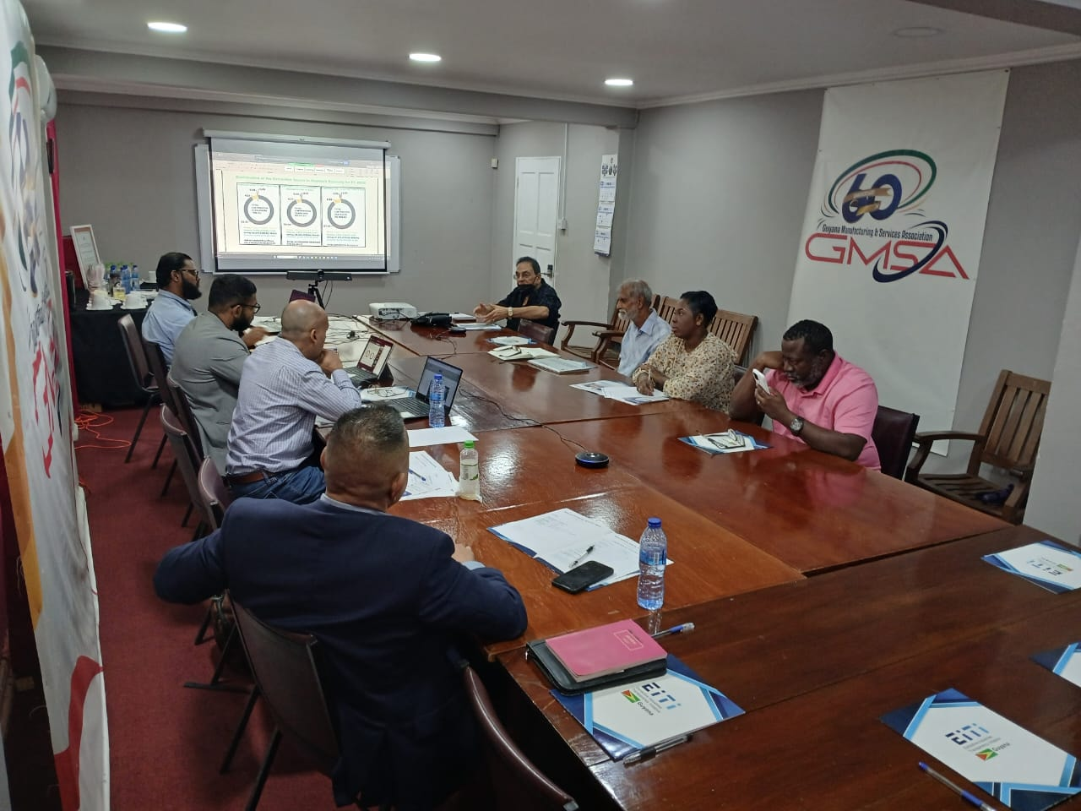

**Challenges and Recommendations**

Despite progress, challenges remain in ensuring full participation from all sectors, particularly in the mining industry. The Secretariat emphasized the need for improved communication and outreach strategies to involve more stakeholders in the EITI process. Recommendations include enhancing the accessibility of information and fostering a culture of transparency among citizens and businesses alike.

**Conclusion**

The meeting concluded with a commitment to continue promoting transparency and accountability in the extractive sector. The EITI's role in ensuring that citizens benefit from the country's natural resources was reiterated, along with the importance of collaborative efforts among stakeholders to achieve these goals.

The engagement served as a reiteration of the vital role that transparency plays in managing the extractive industries and the ongoing efforts required to engage all stakeholders in this process.

Questions:

1. I do appreciate that GYEITI promotes accountability and transparency in the management of natural resources of the extractive industry--particularly petroleum and mineral resources--and highlights how government corruption in the management of these resources (the citizenry's patrimony) contributes to heightened poverty (resource curse...Dutch Disease...). However, is it within GYEITI's purview to also highlight how multinational corporations and expat operators' taking the giant's share of the proceeds from natural resource development contributes to the exacerbation of high levels of poverty in resource-abundant developing countries?
2. You referenced the lack of citizen scrutiny of natural resource development. Is this lack of citizenry scrutiny or oversight as result of lack of interest on the part of citizens, or might there be other factors at play?
3. By GYEITI's metrics, how does Guyana rank on the Transparency Index?
4. Can you please elaborate on the tax waiver mechanism?
5. What is the nature of the mining done by the mining companies that reported?