**GYEITI head discusses transparency matter with US officials.**

On March 24, 2022, GYEITI National Coordinator Dr Prem Misir met with the U.S. Deputy Assistant Secretary (DAS) for Caribbean Affairs and Haiti USAID Barbara A. Feinstein (second from left and her colleague at extreme left), US Ambassador to Guyana Sarah-Ann Lynch (third from left), and Chloe Noble, US Embassy official (extreme right). To the extreme left is Kelly McCray who accompanied Ms Feinstein to Guyana.

The US Embassy meeting on GYEITI centered, among other things, on its strategic vision, strategic priorities, strategy/structure/staffing, relationship between its annual work plan and a strategic plan, beneficial ownership, revenue forecasting, criteria for MSG membership, reconciliation, public benefit, its relationship to SDGs, data collection template for the IA report, status of the 2019 IA report, and schedule of commencing the IA 2020 report.

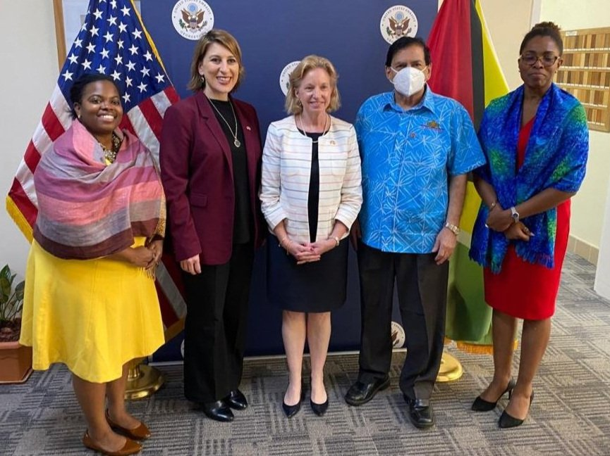

[GYEITI head discusses transparency matter with US officials - EITI](https://eiti.gy/gyeiti-head-discusses-transparency-matter-with-us-officials/)