**Report: Human Rights and Anti-Corruption Expo - December 9-10, 2024**

Theme:  
Building Resilience: Safeguarding Human Rights and Combating Corruption

**Overview:**  
The GYEITI’s engagement with the Human Rights and Anti-Corruption Expo was a resounding success in its mission to promote awareness and education about human rights and anti-corruption measures.

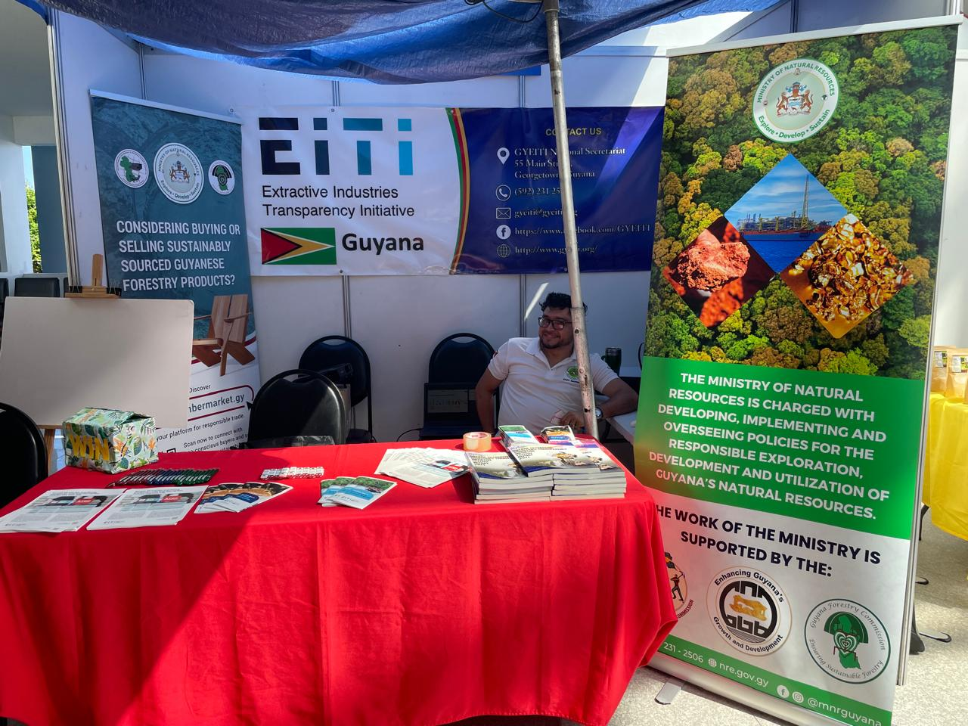

**Execution:**  
Despite a few challenges, the event proceeded smoothly, with most activities and items effectively executed as planned. Here’s a breakdown of key highlights and outcomes:

**Event Highlights**

1. **Interactive Booths and Displays:**
   * **Educational Materials:**
     + Over 500 brochures and flyers distributed, providing insights into EITI's role in fighting corruption and protecting human rights.
     + Posters and banners visually captured the attention of attendees, emphasizing transparency in extractive industries.

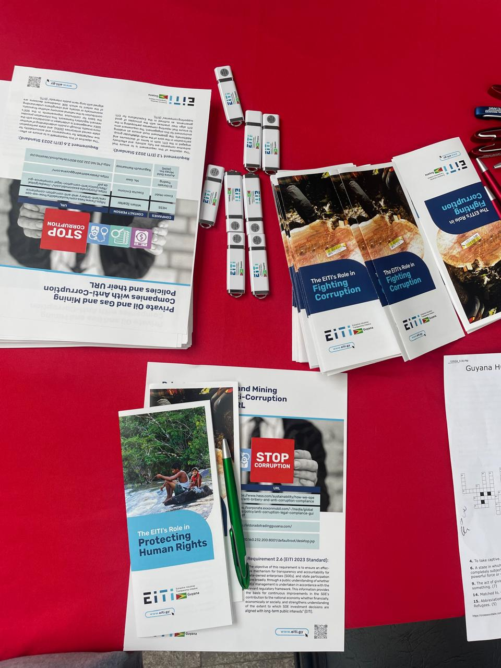

* + **Human Rights Pledge Wall:**
    - Participants actively engaged by sharing commitments on the pledge wall using markers and sticky notes.

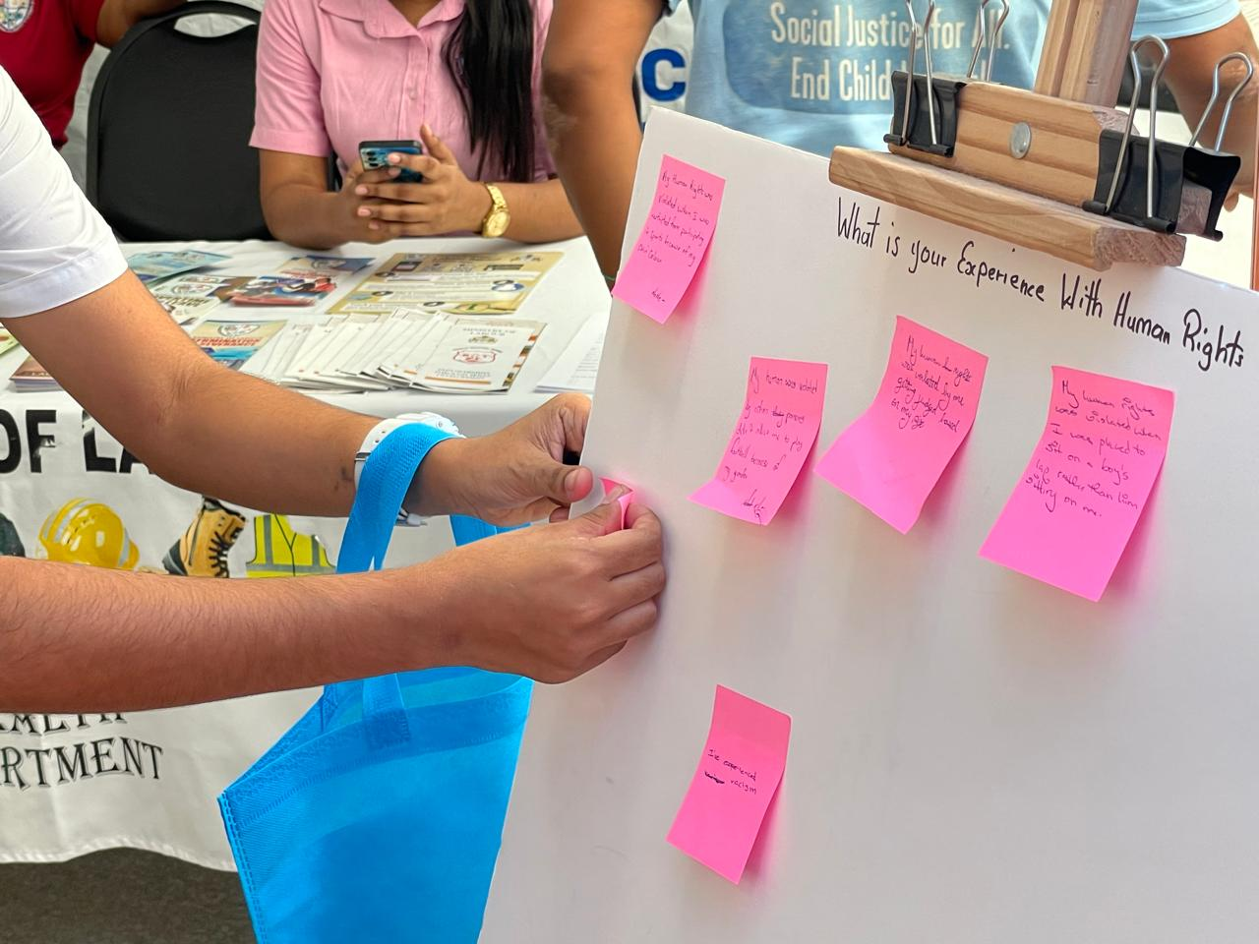

1. **Engagement Activities:**
   * **Quick Presentation Spot:**
     + While technical issues with sunlight affected the visibility of the PowerPoint presentations, the team innovatively adapted by verbally explaining key points to visitors, ensuring impactful communication.

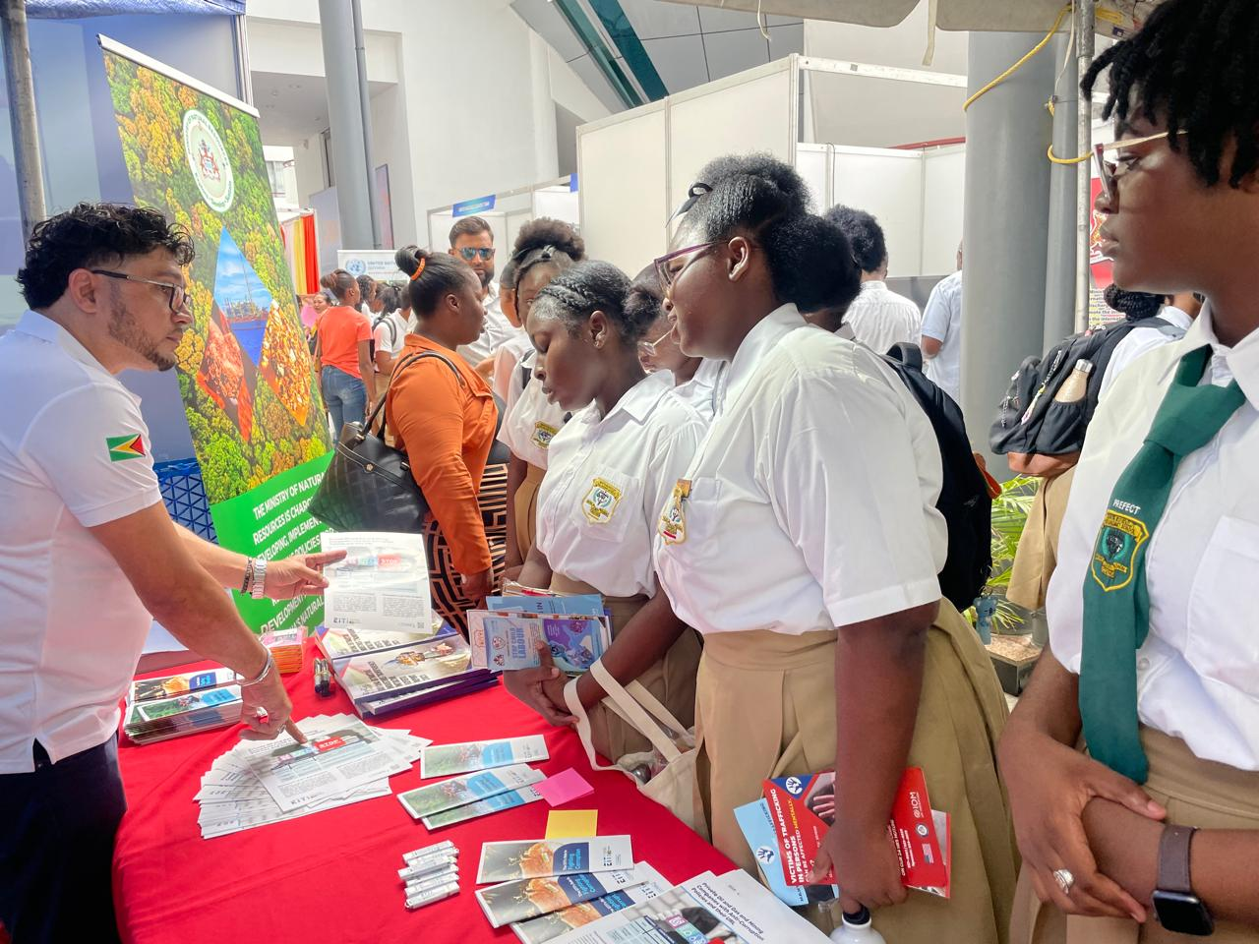

* + **Games and Prizes:**
    - The Draw Box Game was a hit, encouraging participation while reinforcing the day’s theme. Winners were delighted with educational prize packages.

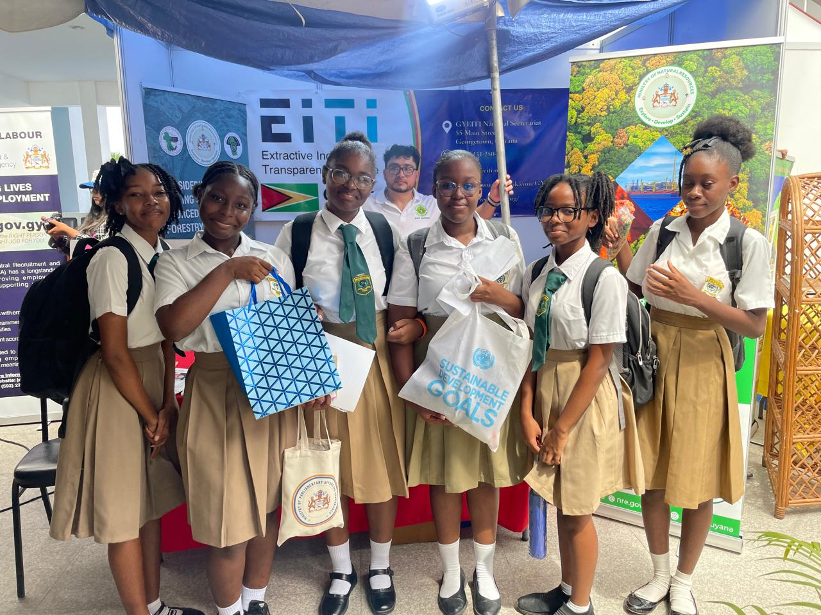

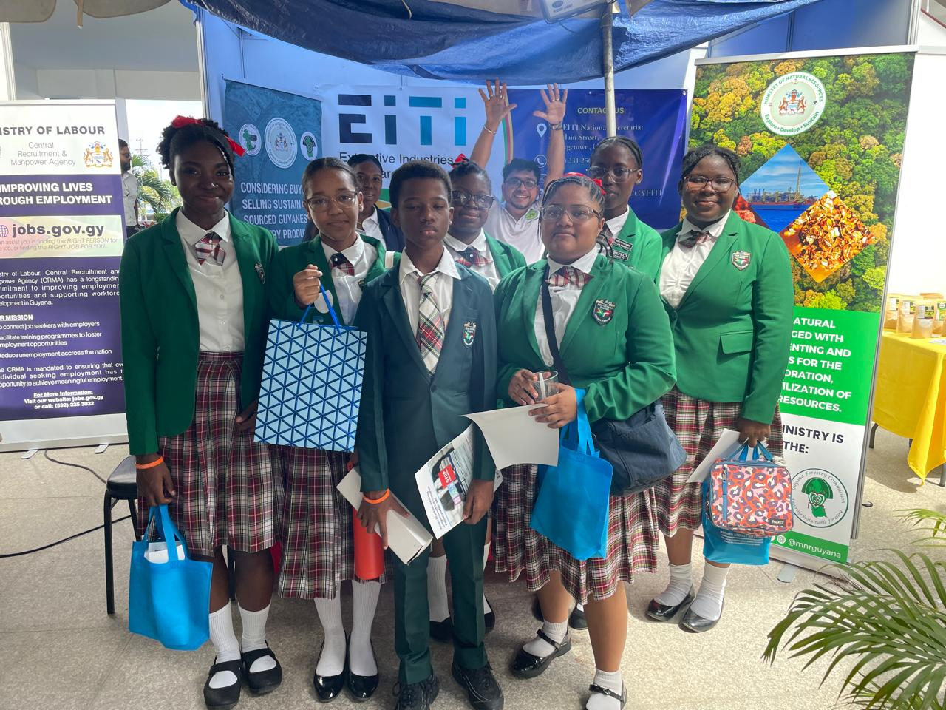

1. **Creative Corner for Kids:**
   * Activities for children, including colouring sessions, provided a family-friendly element to the expo and introduced younger audiences to concepts of human rights and anti-corruption.

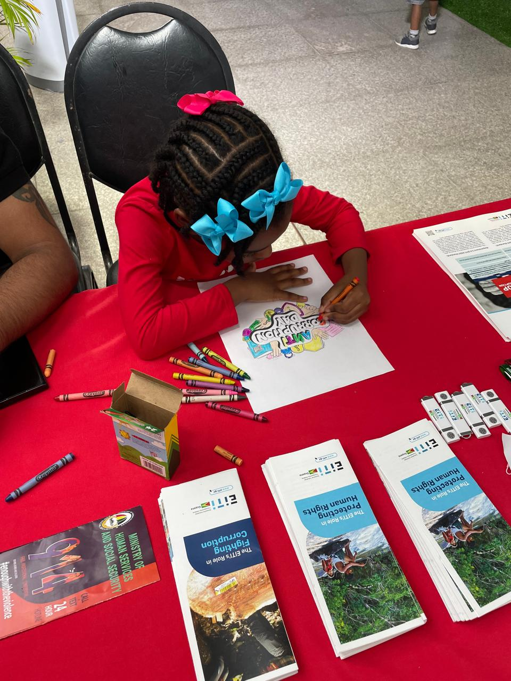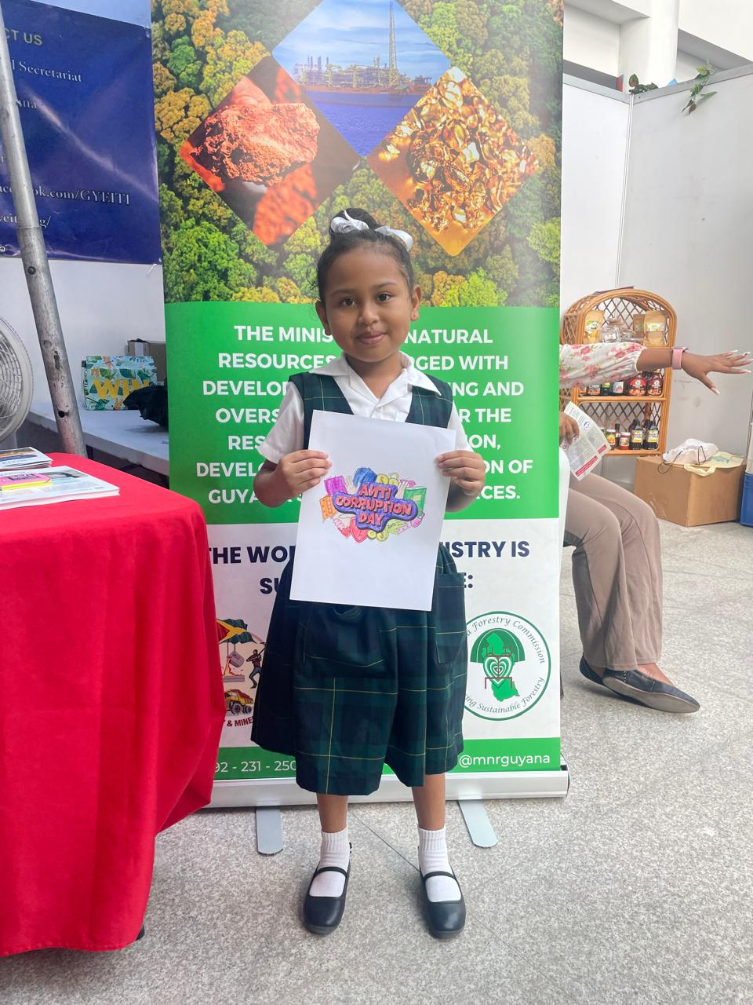

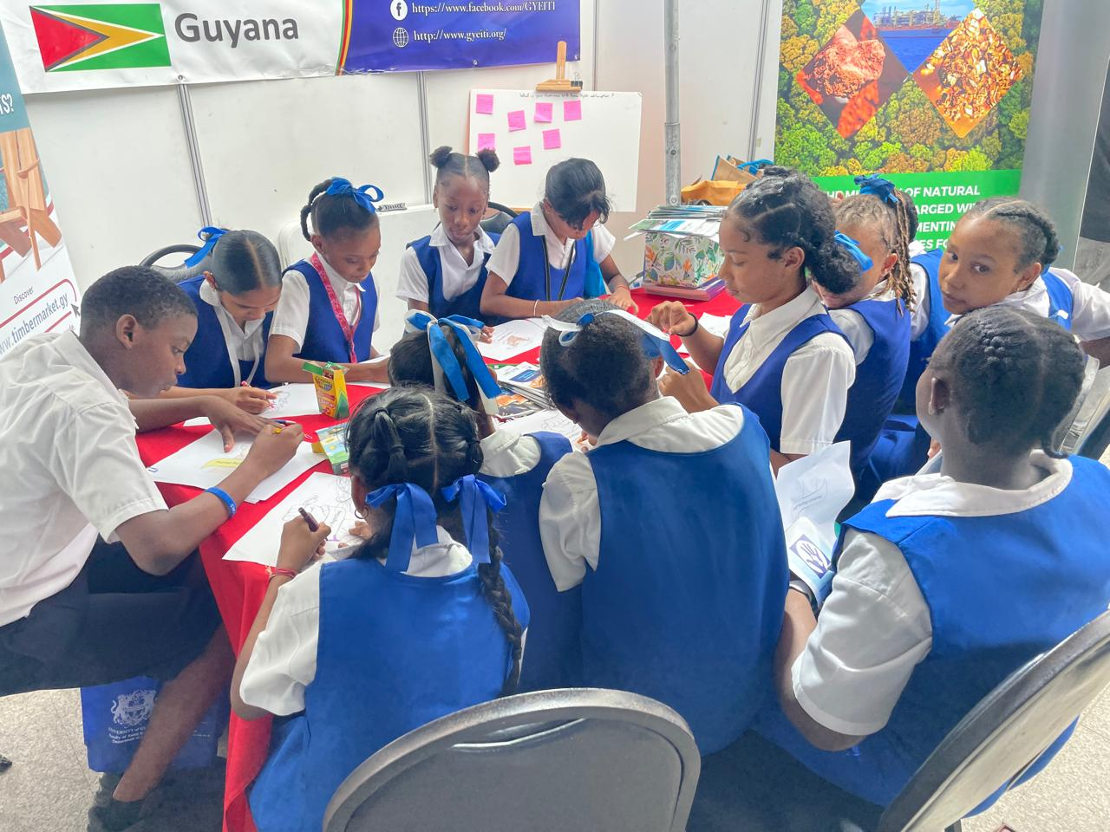

1. **Participants’ Suggestions and Comments:**
   * A participant, a representative from the Guyana Prison Service, suggested collaborating with anti-narcotics agencies and the Customs Anti-Narcotics Unit (CANU).   
       
     “I’d suggest collaborating with anti-narcotics and CANU because a lot of the corruption we see ties back to illegal drug trafficking and smuggling. These activities often go hand-in-hand with other criminal operations, like money laundering, which can creep into sectors like mining and oil if we’re not careful. By teaming up with anti-narcotics agencies, we could track and cut off these illegal channels, ensuring the money made in extractive industries is clean and used properly. Plus, CANU already has systems and expertise in monitoring and catching these networks, so bringing them in would add an extra layer of oversight and transparency. It’s about closing gaps in the system and ensuring everyone plays by the rules—whether it’s the small guys or the big corporations. This kind of partnership would make it harder for anyone to use the extractive industries as a front for dirty money or shady deals”.

**Challenges Encountered**

1. **Video Booth:**
   * Due to lack of participant consent, planned video recordings could not be executed. The team respected privacy concerns.
2. **Presentation Visibility:**
   * Sunlight at the booth location limited the effectiveness of the projector visuals. Alternative methods, such as direct engagement, ensured continuity in delivering the message.
3. **Booth Location:**

* The second day of showcasing was significantly impacted by extensive rainfall, which led to flooding in the surrounding area and water leakages within our booth. These challenges hindered our ability to effectively present our offerings. Additionally, during periods of dry weather, the booth area became extremely hot, creating an uncomfortable environment for both staff and visitors.

1. **Attendees’ Participation:**

* While we greatly appreciate the dedication of the attendees in participating, there is room for improvement in ensuring active involvement at the booth. Challenges arose when one person was left alone to manage the booth, while other attendees spent extended periods away. This situation is not ideal and does not align with the collaborative effort, required.

We understand the desire to visit other booths; however, the time spent away was excessive, resulting in reduced participation and support at our booth. A more balanced approach would enhance both individual engagement and overall team presence.

**Achievements and Impact**

* Raised significant awareness about transparency in the extractive industries and how EITI supports good governance.
* Distributed branded giveaways, including pens and flash drives, which were well-received by attendees.
* Promoted collaboration by linking anti-corruption measures with human rights safeguards, as reflected in the expo’s theme.
* Received valuable feedback from stakeholders, which will guide future initiatives.
* The event received media coverage, further amplifying the message of safeguarding human rights and combating corruption.

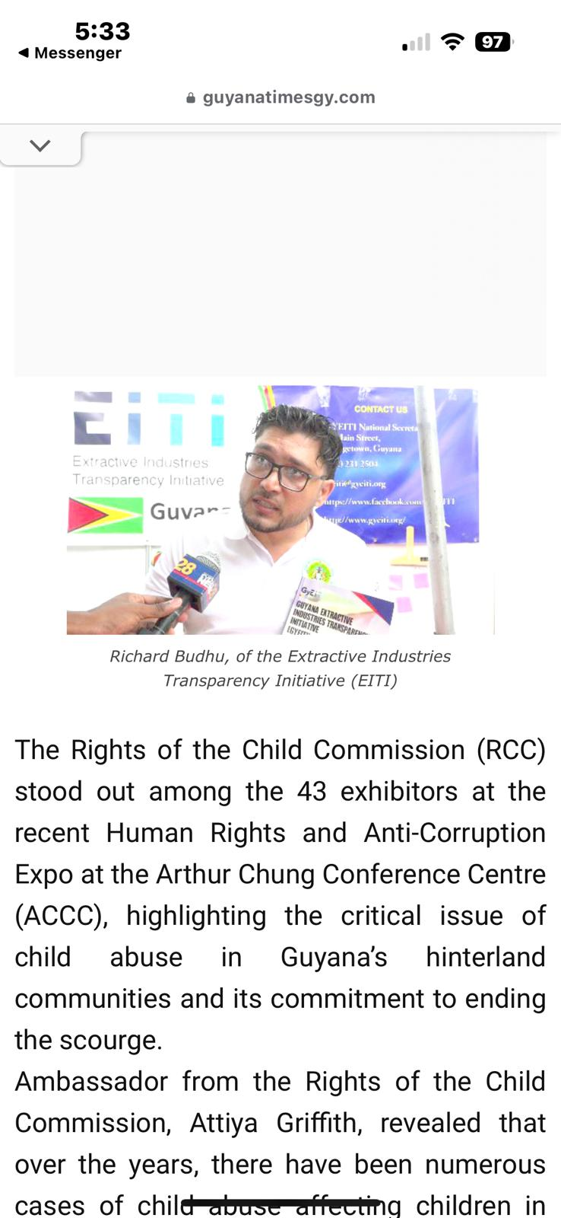

**Acknowledgment:**  
The success of this event was due to the dedication of the organizing team which included Anele Barton, Richard Budhu, Bharat Chunilall and Onica Dowridge, whose commitment to spreading awareness and promoting GYEITI’s values was evident throughout the expo. This effort has laid a strong foundation for continued advocacy in safeguarding human rights and combating corruption.

